**Advance Excel Assignment 15**

Use the above dataset and answer the following questions.

1. Create a Pivot table and show what the main export product is?

Ans. Scale

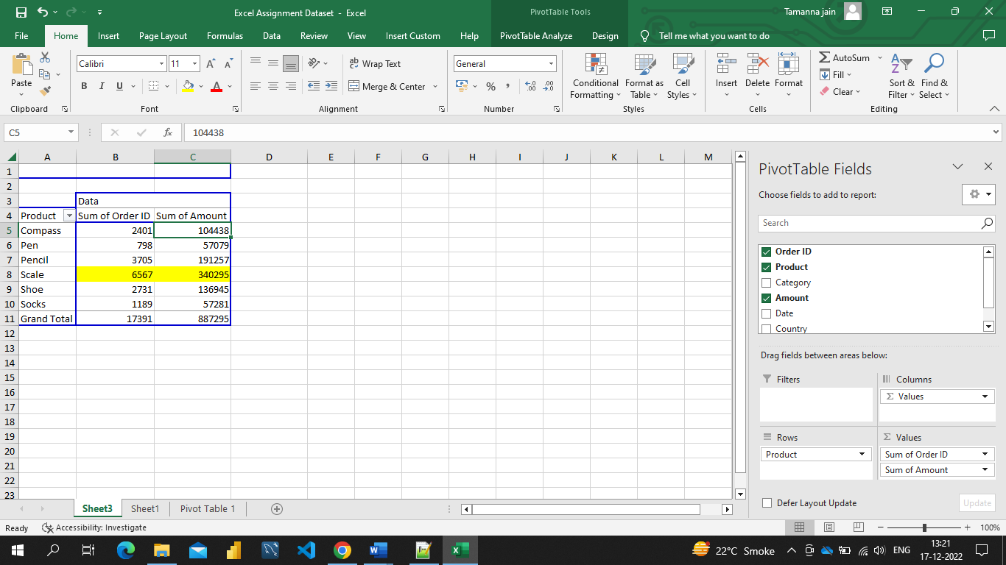

1. Create a bar graph showing the amount spent for each product?

Ans.

1. Create a Pivot Table to show the sales in each city.

Ans.

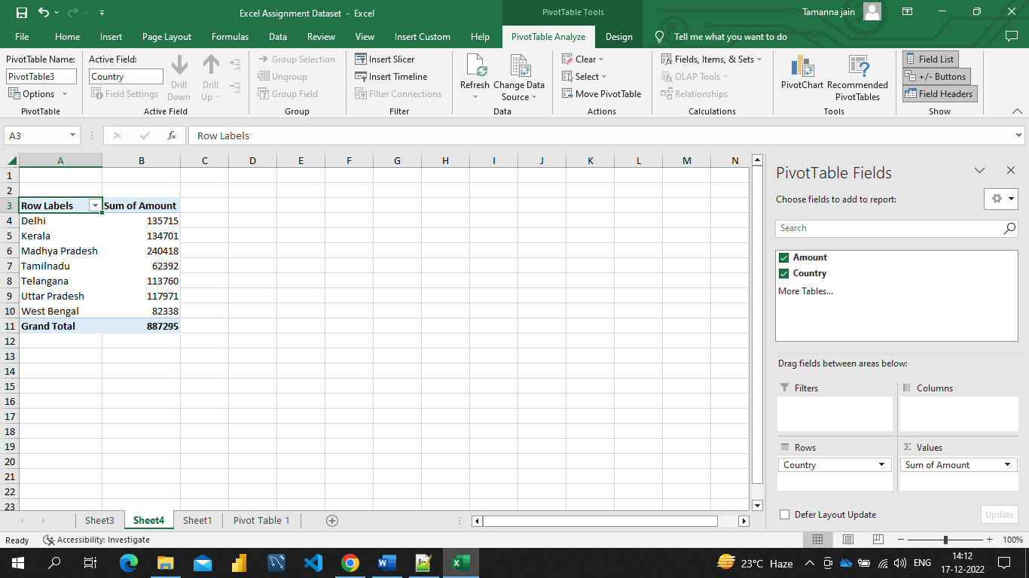

1. Create a chart showing the amount spent for each product in each city.

Ans.